Upgrade Guide

Upgrade through the system interface
- Check the current hardware version of UTG9000T. Download the corresponding version firmware from the official website.
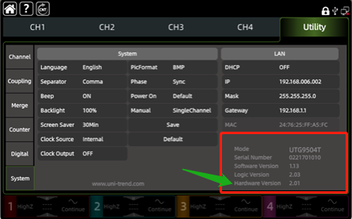
- Save the firmware to be upgraded in the root directory of the U disk
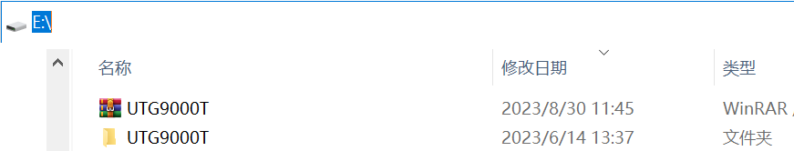
- Insert the U disk into the USB interface of UTG9000T. The instrument will recognize the U disk and pop up a pop-up box "Upgrade file detected，upgrade now?". Click "OK" to confirm and start the upgrade.
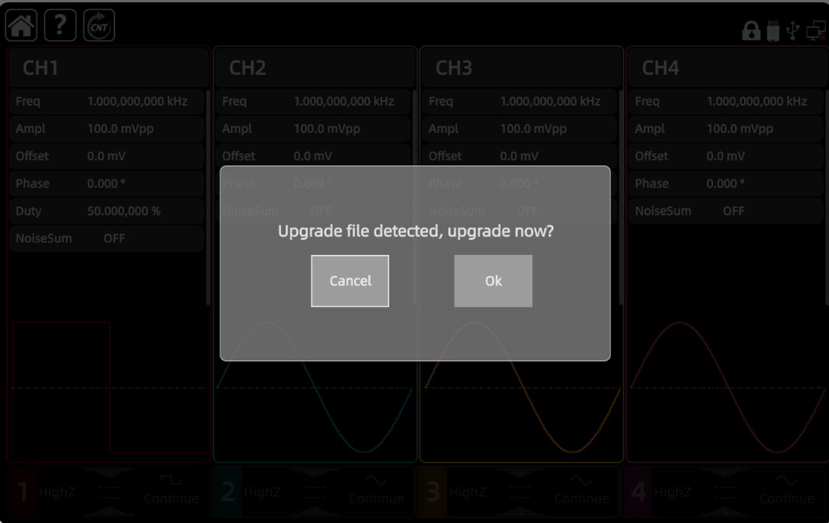
- Wait for the upgrade progress to complete, and the instrument will automatically restart without intervention.
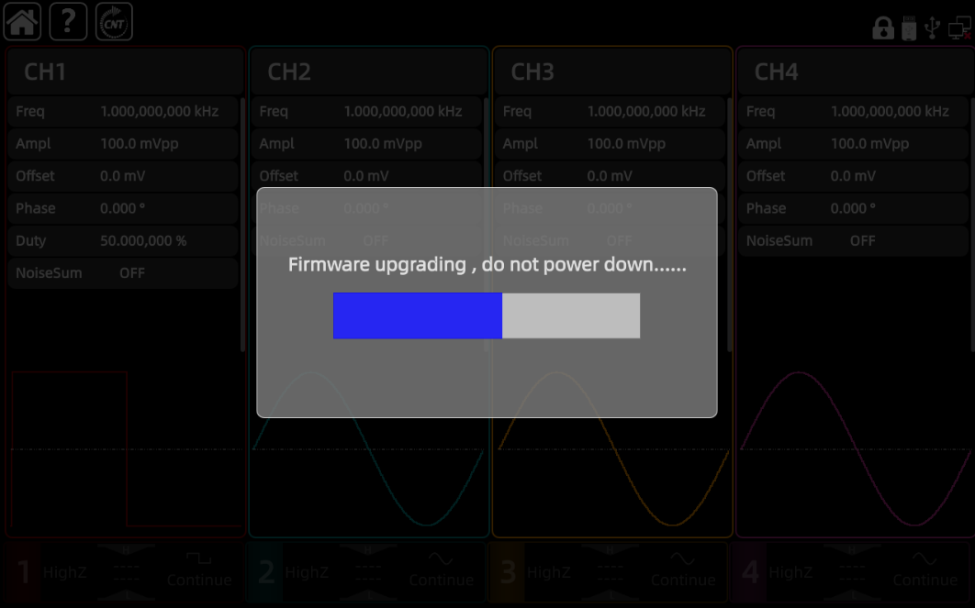
- After the instrument restarts, unplug the USB flash drive. Enter the system information page to view the current version information.
